DUE FRIDAY, APRIL 17 -WRINKLE IN TIME: Essential questions: How have the plot, characters, and themes developed in Chapters 1-4?
How do the characters communicate and why is this significant? How is evil portrayed in this book so far?
PART ONE: Synthesize/summarize your understanding and evaluation of the important theme so far of knowledge vs. wisdom and give examples of how they have been displayed in the first 5 chapters (include point of view-perspective, quotes from characters, etc.)
CHAPTERS 6
PART TWO: PREPARE AT LEAST ONE OF YOUR OWN HIGH ORDER THINKING QUESTION ALONG WITH YOUR OWN THOUGHTS ABOUT IT.
PART THREE: VOCABULARY: define and identify the correct part of speech
- Arrogance
- Talisman
- Apprehension
- Resilience
- Malignant
- falter

PART FOUR: REFLECT AND RESPOND CAREFULLY:

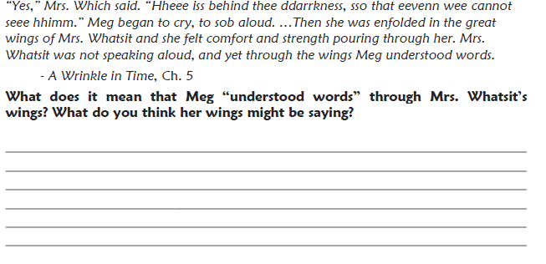
- 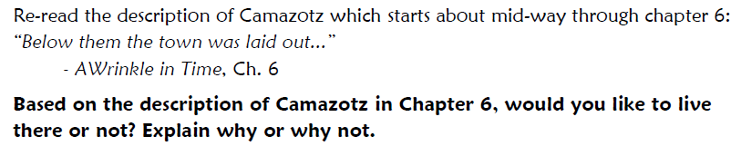
- What does the black thing represent? How might it fit into the theme of good vs. evil? How is the dark thing threatening the earth?
- Find at least two other examples of characters or things that represent good or evil and explain how they “fight.”
- Camazotz may be an allusion to “Camelot.” Find out what Camelot was and try to explain its significance.
- Why do you think Mrs. Who quoted from Shakespeare’s The Tempest?
- How do you think Mrs. Whatsit’s parting gifts to each of the children will be important?
- How does the metaphor of the stars work in the ongoing struggle between darkness and light? Explain the metaphor of the star giving up its life to fight the Darkness. How do you feel about the revelation that Mrs. Whatsit was once a star?

