The Great White Shark
By:Isabelle Chen

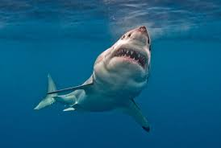

The Great White Shark

Intriguing Introduction

Great White Sharks are intelligent creatures. They have special features and ways to survive. The legendary Great White Shark is far more fearsome in our imaginations than in reality. As scientific research on these elusive predators increases, their image as mindless killing machines is beginning to fade. This info graphic will teach you about the Great White Shark.

Specific Special Shark

Of the 100 - plus annual shark attacks worldwide, fully one - third to one - half are attributable to Great White Sharks. However, most of these attacks are not fatal, and new research finds that Great White Sharks, who are naturally curious, are “sample-biting" then releasing their victims rather than preying on humans. It's not a terribly comforting distinction, but it does indicate that humans are not actually on the Great White Shark's “menu”.
Great White Sharks are the largest predatory fish on Earth. They grow to an average of 15 feet or 4.6 meters in length, though specimens exceeding 20 feet or 6 meters and weighing up to 5,000 pounds or 2,268 kilograms have been recorded.
The Great White Sharks have gray upper bodies to blend in with the rocky coastal sea floor, but get their name from their universally white underbellies. The Great White Sharks are streamlined, torpedo - shaped swimmers with powerful tails that can propel them through the water at speeds of up to 15 miles or 24 kilometers per hour. They can even leave the water completely, breaching like whales when attacking prey from underneath.
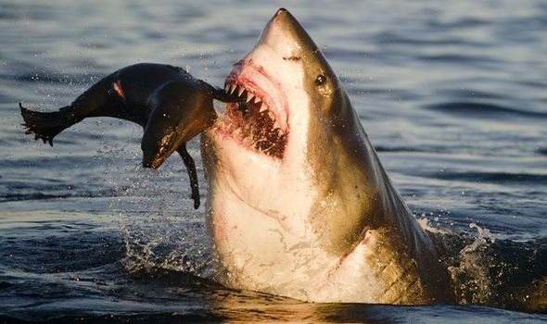

This is a Great White Shark eating A Siberian Seal.

Yummy Yumidtey Yum Yums

Highly adapted predators, the Great White Sharks mouths are lined with up to 300 serrated, triangular teeth arranged in several rows, and they have an exceptional sense of smell to detect prey. The Great White Sharks even have organs that can sense the
tiny electromagnetic fields
generated by animals. Their main prey items include sea lions, seals, small toothed whales, and even sea turtles and carrion.

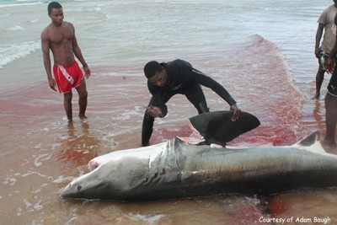
Especially Endangered
Found in cool, coastal waters throughout the world, there is no reliable data on the Great White Shark's population. However, scientists agree that their number are decreasing precipitously due to overfishing and accidental catching in gill nets, among other factors, and they are listed as an endangered species. The Sea Shepherd Conservation Society is a non - profit organization dedicated to protecting the marine environment. Their work with Great White Sharks focuses on trying to protect these giant fish from illegal "shark finning". Great White Sharks are often caught and killed for their fins, which are used to make Shark Fin Soup, a delicacy in many countries. Great White Sharks are caught, killed and their fins are removed before their bodies are dumped back in the water. Most of the Sharks killed are Great White Sharks, because those sharks have the largest fins out of all of the shark species. Since many of these practices occur, many Great White Sharks are already extinct.

Ways To Help Save The Great White Shark,
Refuse to eat shark fin soup and do not eat in restaurants that serve shark fin soup. Spread the word to your peers about illegal shark fishing. Convince your parents to make your next vacation at a shark - friendly place. Consider going diving with the sharks as part of an "eco - tourism" package. The more money that goes into this kind of tourism, the more governments will realize that saving not just Great White Sharks, but all sharks is just plain smart.
Concluding Conclusion
The Great White Shark is less gruesome than you think. As we speak, the number of Great White Sharks are decreasing. Eventually, that number will hit a point until there is no possible way to save these creatures. It is best for us to save the sharks now. When it is still possible to do.

Power Word Definitions
Intelligent - (Adjective) Smart
Elusive - (Adjective) Difficult to find, catch, or achieve
Great White Shark - (Noun) A species of shark
Fatal - (Adjective) causing death
Distinction - (Noun) excellence that sets someone or something apart from others
Specimen - (Noun) an individual animal; plant; piece of a mineral, etcetera, used as an example of its species or type for scientific study or display
Universally - (Adverb) by everyone, in every case
Streamlined - (Verb) design or provide with a form that presents very little resistance to a flow of air or water, increasing speed and ease of movement
Breaching - (Verb) rise and break through the surface of the water.
Adapted - (Verb) make (something) suitable for a new use or purpose; modify.
Serrated - (Adjective) having or denoting a jagged edge; sawlike
Precipitously - (Adjective) extremely or implausibly steep
Eco - tourism - (Noun) tourism directed toward exotic, often threatened, natural environments, especially to support conservation efforts and observe wildlife
Gruesome - (Adjective) causing repulsion or horror
Fast Fun Facts
Type: Fish
Diet: Carnivore
Size: 15 ft or 4.6 meters to more than 20 ft or 6 meters
Weight:
5,000 pounds or 2,268 kilograms or more
Group name: School or shoal
Did you know?
Great White Sharks can detect one drop of blood in 25 gallons or 100 liters of water and can sense even tiny amounts of blood in the water up to 3 miles or 5 kilometers away.
Size relative to a bus:
This Great White Shark is at full size

