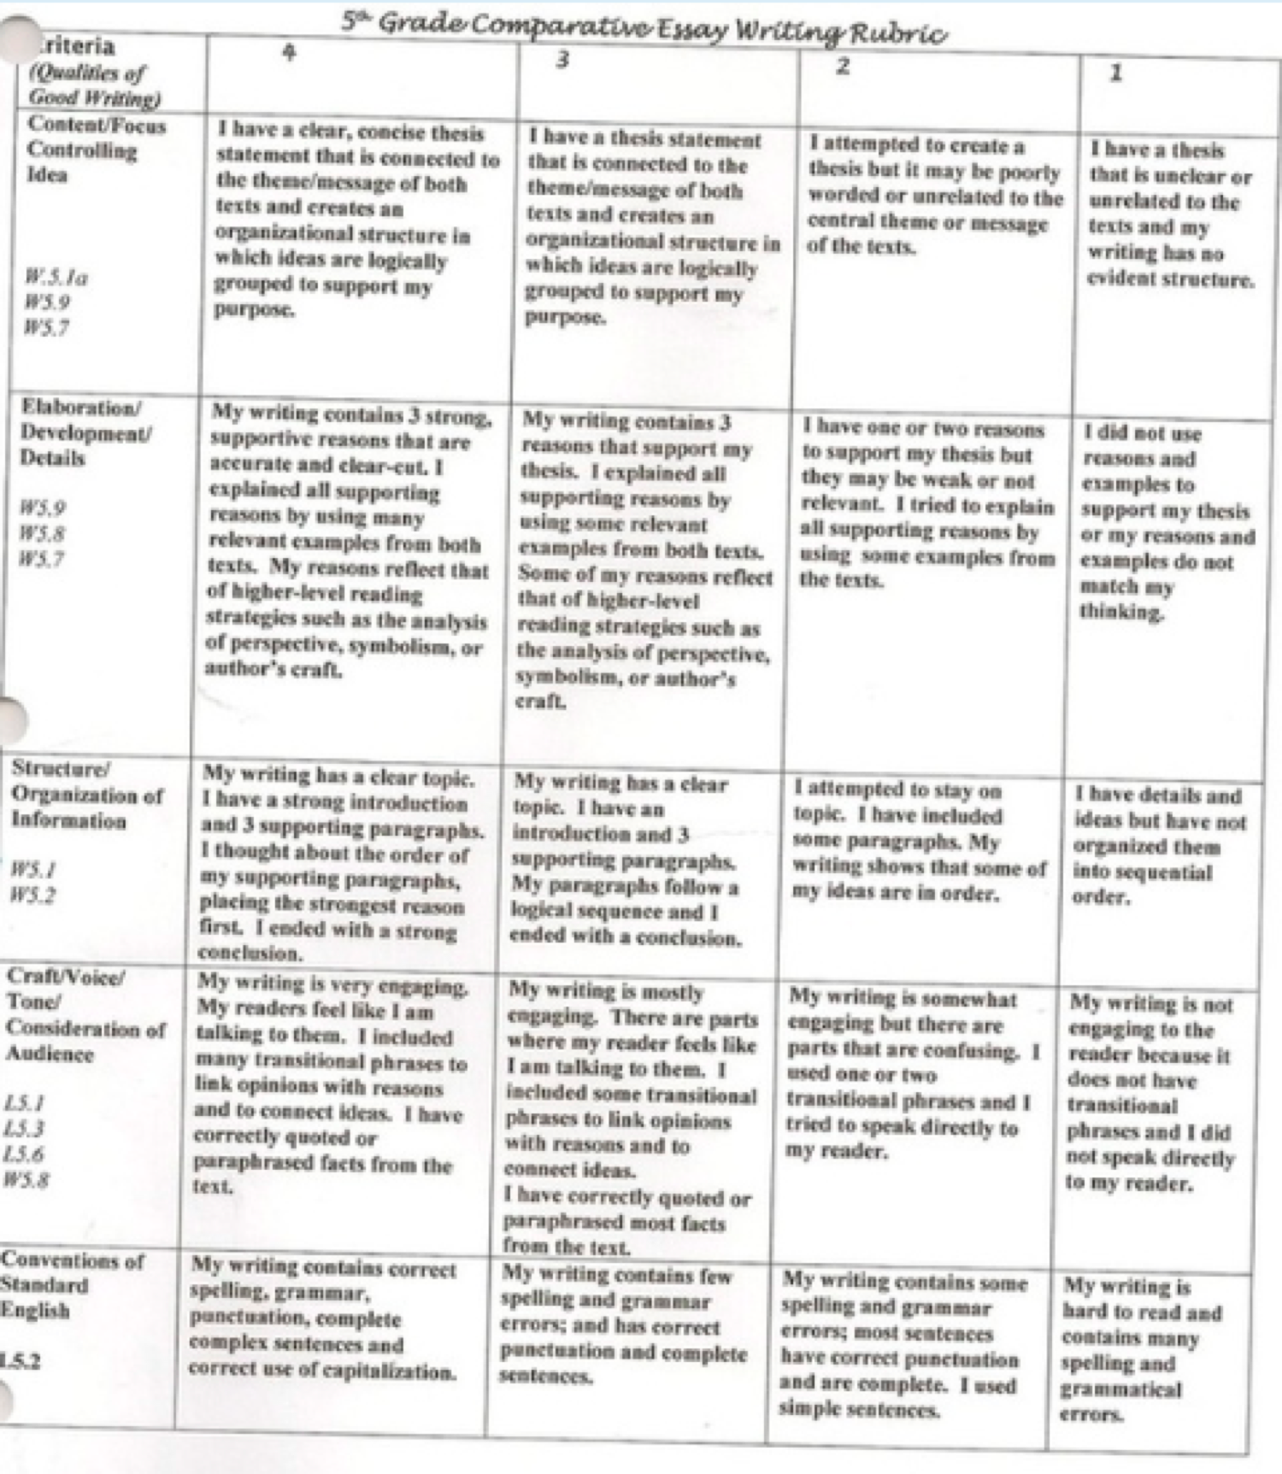

Task for Comparative Essays Using: Last Kiss and Growing Pains

Read The Short Story Last Kiss by Ralph Fletcher and the poem Growing Pains by
Jean Little. You will use the two passages to compare and contrast the text with
similar themes and develop a thesis/ claim that applies to both stories and a
common message.

In your response, be sure to:

- Introduce a topic

- use details from the stories to support your answers

- Organize ad connect your ideas in your writing

- Provide a closing statement in your writing

- Use transition words
- Check your writing for complete sentences, capitalization, punctuation and

Spelling.
.
Please use the comparative essay structure handout I gave to determine the best structure:
