How can we incorporate our solutionary work into creating & conducting surveys about our important topics-issues, create frequency tables & display our data using bar graphs, fractions, decimals and percents and reflecting on our findings?

Use the following website to help guide your work: https://www.mathsisfun.com/data/survey-conducting.html

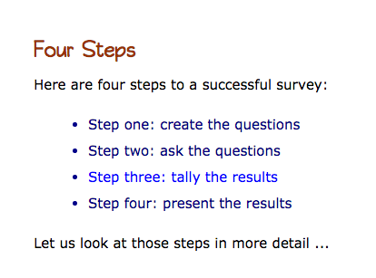

Task: You will be creating and conducting a survey about an important topic that connects to the work you are doing with your solutionary teams. You will creat an objective-goal, come up with 4-5 relevant survey questions with relevant choices, create frequency tables and display your data using bar graphs, picto-pie graphs, charts that display fractions, decimals & percents and then reflect on your findings.

PART ONE: CREATE AN OBJECTIVE. EXAMPLE:
OBJECTIVE: To find out how often kids drink milk, what their favorite type of milk is, if they drink non-dairy milk and if they would drink non-dairy milk if it was offered in the school cafeteria. I know some kids are allergic to milk or just don’t like it. Also, we are finding out that sometimes milk has ingredients like palm oil in it which is not good for animals’ habitats and leads to deforestation. There may also be ethical concerns about the way dairy animals are treated. So I want to find out if kids have tried alternative milks and if they would actually drink them lunchtime.

PART TWO: Come up with at least four and no more than 5 relevant questions that relate to your topic. Example:

- What is your favorite kind of dairy milk?
- What is your favorite non-dairy milk?
- How often do you drink milk?
- If non-dairy milk was offered in the cafeteria, would you drink it?
Part Three: Set up a frequency table with relevant choices. EXAMPLE:
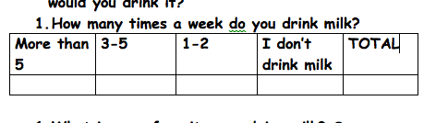

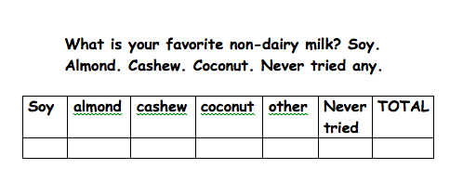
- If you could choose bet. Dairy and non-dairy milk, which would you choose?
Regular whole milk | Low fat regular milk | Chocolate dairy milk | Soy | almond | Choc. Non-dairy | OTHER | NONE | TOTAL

- If non-dairy milk was offered in the cafeteria, would you drink it or be willing to try it?
yes | No | total
Part Three: Conduct your survey using reasonable sample size. For example, you should probably stick to kids about your age—grades, three and four. You may survey classmates but will probably also want to survey other kids, too. Try to survey at least 50 kids in total. Make sure you display all of your results in a frequency table using tally marks.

Part Four: Display your data in a chart-table that compares decimals, fractions and percents.
For ex: Kids willing to try or drink non-dairy milk in cafeteria
Yes-36 | 36/50=18/50 | .68 | 68%
No-14 | 14/50 | .32 | 32%
***Remember to change fraction into decimal, divide numerator by the denominator.

Part Five: Create a pie chart and bar graph to display your data. https://nces.ed.gov/nceskids/graphing/classic/bar.asp
https://nces.ed.gov/nceskids/graphing/classic/pie.asp

Part Six: Analyze your data. Discuss what your survey shows. Also, describe whether your survey changed or confirmed your thinking. This section should be at least two reflective paragraphs.

