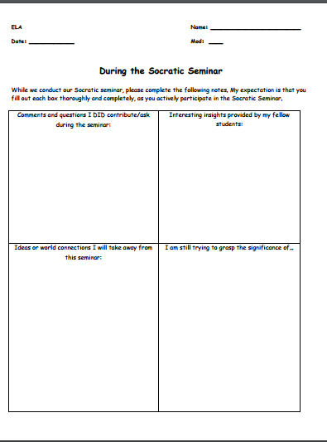

Socratic Seminar Exit Slip
After our Socratic Seminar, you are responsible for completing a one-paragraph reflection. This paragraph should show careful reflection and observation about your Socratic Seminar experience today in class.
Introductory sentence: As a result of my participation in this Socratic Seminar, I feel I deserve a score of 4 points. Three supporting pieces of evidence about your personal participation. TRY TO CAREFULLY ANSWER AS MANY OF THESE QUESTIONS AS POSSIBLE:
What is one thing you liked that you said?
2. What is one point someone else said that you agree with?
3. What was the most interesting question?
4. What was the most interesting idea to come from a participant?
5. What was the best thing that you observed?
6. What was the most troubling thing that you observed?
7. What do you think should be done differently in the next seminar?
8. As a Socratic Seminar participant, what area of the process will you work on for next time?
9. What new questions arose as a result of the discussion?
Concluding Sentence: It is for these reasons that I feel I have earned an exemplary score of 4 on today’s seminar:
