Name: ____________________________________ Date: _______________________ Number:_______
Rock Cycle Project 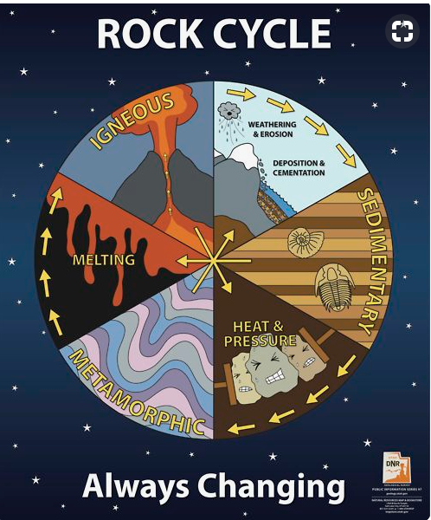
- First, watch the BrainPop video about the Rock Cycle: https://www.brainpop.com/science/earthsystem/rockcycle/
Take the Brainpop quiz.
Then, use the following links and any other research to help you complete the project below.
- Part A:
Write a summary and response to the following article on Newsela. Use the Current Events form to record your work. You may also add an image:

https://newsela.com/read/wyoming-devilstower/id/8004/

- Part B: Draw a diagram of the Rock Cycle. The following sites can help you:
https://www.learner.org/interactives/rockcycle/rockdiagram/
https://www.kidsdiscover.com/infographics/infographic-rock-cycle/
http://www.ducksters.com/science/rocks.php

SAMPLE COMIC STRIP-DO NOT PLAGIARIZE BUT USE AS A MENTOR TEXT IF YOU WISH TO CREATE YOUR OWN.
Part C 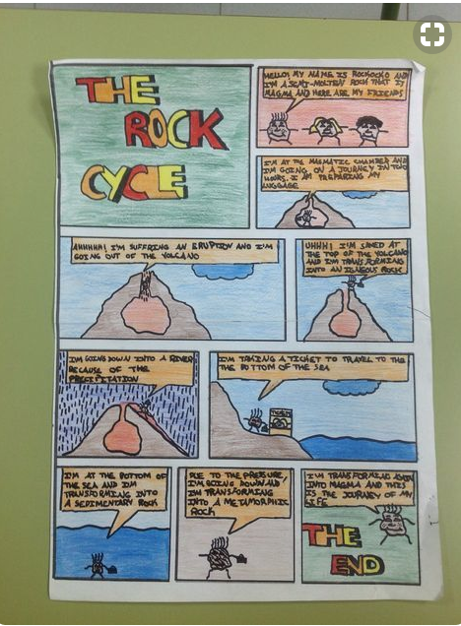
Complete one of the 2 projects:
- Write A JOURNEY ON THE ROCK CYCLE. In this activity you will create a story about you, a metamorphic rock. You must describe at least three transitions that occurred during your life, such as changing from metamorphic to igneous, igneous to sedimentary, and sedimentary to igneous. You have the option of writing a diary, creating a comic strip, or making a children's book. Write a fictional narrative from the perspective of a rock moving through the rock cycle. Your narrative should be at least one page long.
- Create an informational picture book about the rock cycle. Your book should be at least 5 pages long and include illustrations and text on every page.

Informational:
 | 1 | 2 | 3 | 4
Overall | The writer taught readers information about a subject. The author put in ideas, observations, questions. | The writer taught readers different things about a subject. He put facts, details, quotes, and ideas into each part of his writing. | The writer used different kinds of information to teach about the subject. Sometimes she included little essays, stories, or how-to sections in her writing. | The writer conveyed ideas and information about a subject. Sometimes he incorporated essays, explanations, stories, or procedural passages into his writing.
Organization | The writer grouped her information into parts. Each part was mostly about one thing that connected to her big topic. | The writer grouped information into sections and used paragraphs and sometimes chapters to separate those sections. Each section had information that was mostly about the same thing. He may have used headings and subheadings. | The writer organized her writing into a sequence of separate sections. She may have used headings and subheadings to highlight the separate sections. | The writer used subheadings and/ or clear introductory transitions to separate his sections. The writer chose structures and text features to help emphasize key points. The writer used transitions, introductions, and topic sentences to pop out his main points.
Science | There were no facts on the pages or there were no matching illustrations/charts/diagrams. | There were a few facts on each page. Some of the pages had matching illustrations/charts/diagrams. | There were some facts on each page. Most pages had matching  illustrations/charts/diagrams. | There were many facts on each page with matching illustrations/charts/ diagrams.
Spelling/  Grammar | There were more than 5 mistakes. | There were 4-5 mistakes. | There were 1-3 mistakes. | There were no mistakes.

Rock Cycle Diagram Checklist:
- I included all the parts of the rock cycle.
- I connected all the parts together correctly.
- I labeled each part of the diagram
- The diagram fills a page.
- The diagram is done neatly.
Feedback:

Narrative Rubric:
 | 1 | 2 | 3 | 4
Overall | The writer told the story bit by bit. The story’s main focus was not the rock cycle. | The writer wrote the important part of an event bit by bit and took out unimportant parts. The main focus was not the rock cycle. | The writer wrote a story focused on the rock cycle, not the characters. | The writer wrote a story that had tension and resolution. The story focused on the rock cycle, not the characters.
Organization | The writer used paragraphs and skipped lines to separate what happened first from what happened later (and finally) in her story. | The writer used paragraphs to separate the different parts or times of the story or to show when a new character was speaking | The writer used paragraphs to separate different parts or time of the story and to show when a new character was speaking. Some parts of the story were longer and more developed than others. | The writer used paragraphs purposefully, perhaps to show time or setting changes, new parts of the story, or to create suspense for readers. He created a sequence of events that was clear.
Science | There were no facts on the pages or there were no matching illustrations/charts/diagrams. | There were a few facts on each page. Some of the pages had matching illustrations/charts/diagrams. | There were some facts on each page. Most pages had matching  illustrations/charts/diagrams. | There were many facts on each page with matching illustrations/charts/ diagrams.
Spelling/  Grammar | There were more than 5 mistakes. | There were 4-5 mistakes. | There were 1-3 mistakes. | There were no mistakes.

Rock Cycle Diagram Checklist:
- I included all the parts of the rock cycle.
- I connected all the parts together correctly.
- I labeled each part of the diagram
- The diagram fills a page.
- The diagram is done neatly.
Feedback:

