Picnic Predicaments

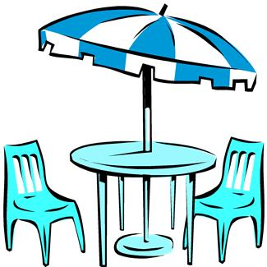Brandon is helping his mother plan a picnic for a family reunion. They are expecting 27 family members to attend, and they are using round tables that seat 5 guests each. How many tables will be needed to seat 27 people? How did the remainder impact the answer to this situation?

Brandon and his sister, Daisy, are preparing flower bouquets as centerpieces for each table at the picnic. They hope to have enough to decorate the table that has all the food as well. They have 43 roses and they would like to put 6 roses in each bouquet. After they have made as many bouquets as they can, how many roses will be left to decorate the food table? How did the remainder impact the answer to this situation?

Brandon’s mom is serving punch at the picnic. She has a punch bowl that holds 34 ounces of punch. How many 3-ounce servings can be poured from the punch bowl when it is full?
How did the remainder impact the answer to this situation?

Daisy is making tablecloths for all of the picnic tables. She has 15 yards of fabric to make 6 tablecloths. How much fabric will she use for each tablecloth?

