MONDAY, November 7, 2016
Good morning! I am not feeling well and will be happy to see you on Wednesday—the day AFTER Election Day. Please work on your scrapbooks including the packet I gave to you on Friday. Use your computers wisely and responsibly and have a great day!!!
Period One: Music prep
Period Two: Science professional period
Period Three: I can respond thoughtfully, thoroughly and critically to current events by reading more about how candidates stand on certain issues, choosing & supporting my own positions on these issues.
Make sure you completed thoughtfully, thoroughly and critically the packet that was handed out on Friday. (It is attached again here). Also read the following article from Newsela:
https://newsela.com/articles/science-candidates-respond/id/22471/
Write a response to summarize the disagreement between any two people (the candidates) or organizations in the article. If you were to support the claims made by only one of these parties, who would it be? Why?
You may add article and your summary-response to election scrapbooks. Save work in google docs or on USB. Printer may not be working.
Period Four: Revisit poem and story about the Hermit Thrush. You can read the Thrush legend here: https://willowhousechronicles.wordpress.com/2010/01/08/how-the-hermit-thrush-found-his-song/ and here:
http://whisperingbooks.com/Show_Page/?book=Legends_Of_The_Iroquois&story=Why_Hermit_Thrush_Is_So_Shy
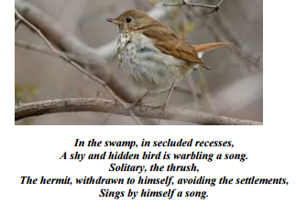
Please make sure you complete the following activities:
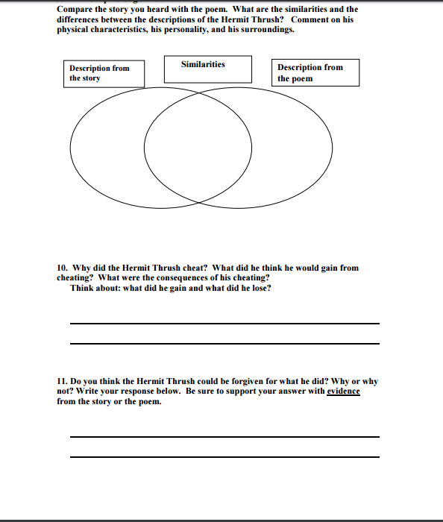
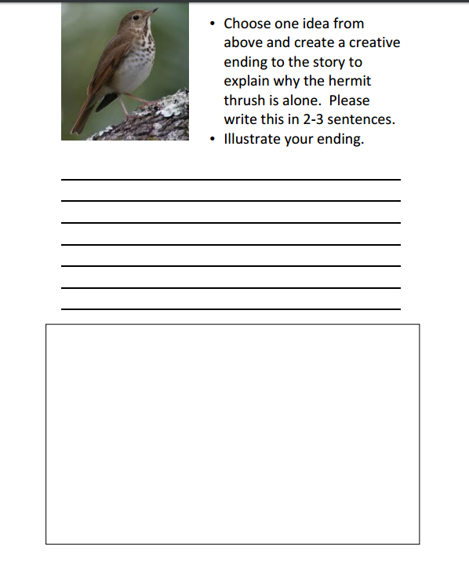
Period Five: Lunch
Periods Six & Seven: Math- Complete enrichment activity 2.11—posted on Think Central. You may also work on problem of the week. You may also participate in math numbers game.
Period Eight: Algonquin and Iroquois webquest. Work in partnerships.

HOMEWORK
Urge parents to go out and vote!
Work on election scrapbooks-due next Tuesday—use rubric and remember presentation counts as much as content
Continue community mapping and start to think about project you would like to work on.
Algonquin-Iroquois webquest is due on Friday

