Ella Chen and Omamah Aziz P.S. 165 Q 11/1/18 5-315

Social Studies Natural Wonders Research Project
Niagara Falls, Ontario

Have you ever heard about the natural wonders of the Western Hemisphere? Well, If you haven’t and if you have, read on to find out about Niagara Falls and Ontario which is one of the Natural Wonders of the Western Hemisphere.

Niagara Falls was discovered by a french explorer named Father Louis Hennepin. There is also a river called Niagara River that runs from Lake Erie to Lake Ontario.

Its a fun fact

Niagara Falls is a waterfall system located along the border between Ontario, Canada and New York, USA. This is one of the oldest State Park in America which was established 1885. Niagara Falls is in the continent North America and the country Canada. Niagara Falls is in between the two twin cities which are Canada and New York. Niagara Falls was not one of the 7 wonders before but then later on, Niagara Falls became one of the new 8th wonder.

Niagara Falls is compromised or built including 3 different waterfalls. These 3 falls are the Horseshoe Fall or the Maid Of The Mist pool, American Fall and the Bridal Veil Falls. The Horseshoe Fall is the largest and the Bridal Veil Falls is the smallest fall. Niagara Falls vertical height is over 176 feet in some sections of the waterfall. During periods of the summer and fall, more than 700,000 gallons of water pour over Niagara Falls per second. Niagara Falls is the second largest waterfall in the world.

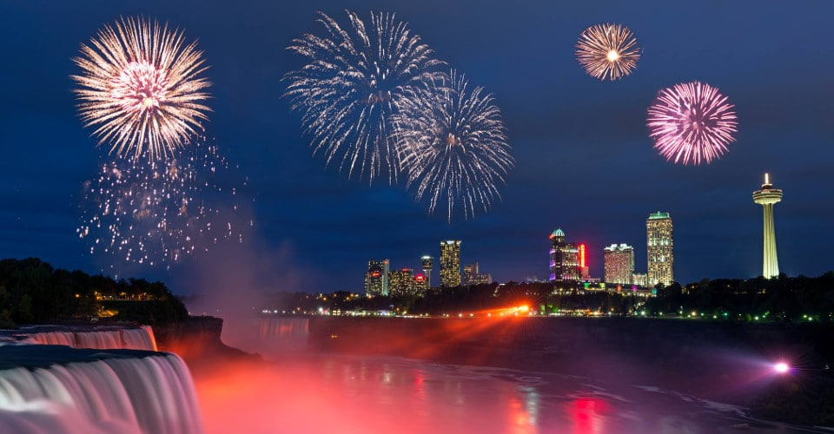
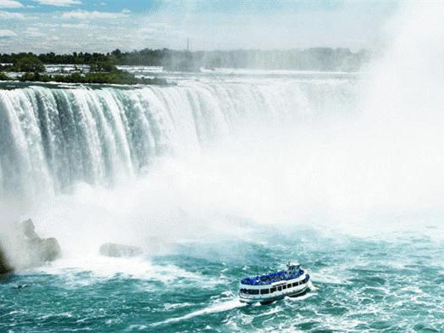
First thing we were able to see when I got there was sprinklings of water everywhere. I recommend going to Niagara Falls over the summer since the water make it a cooler place and it gets a little cold a lot of the time. One of the reasons we love this sight is because at night, the fireworks come out in cool shapes, different sizes and it is so colorful. Another reason we would recommend visiting places like this because it is such a peaceful place and the fresh smell of water is wonderful the only thing you would be able to hear is the water. It sounded like heavy water raining down. Both our most favorite part of this whole trip was the boat, we traveled toward the big fall and it was the coolest thing
ever, it felt like a breeze of wind when it was just calm
water spraying on you.

Fun Fact: The first person to go over Niagara Falls in a barrel was a 63 year old school teacher named Annie Edson Taylor.

Nik Wallenda was the first person to go over Niagara Falls in a tightrope.

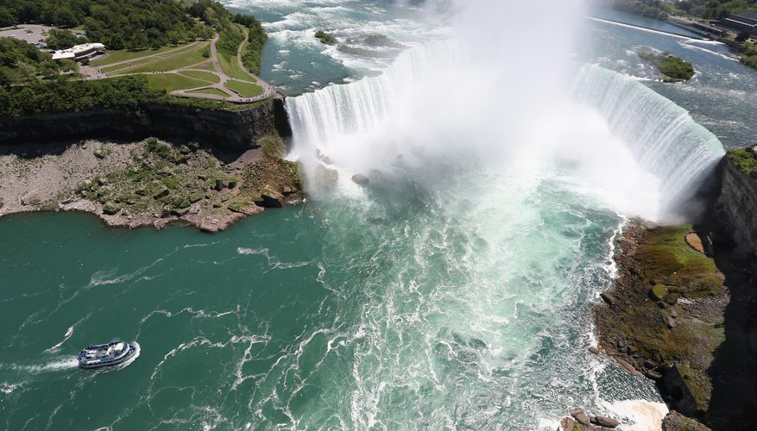
Niagara Falls was formed when Glaciers made its way at the end of the Wisconsin Glaciation which was the last ice age. The formation of Niagara Falls was a slow process that still continues today.
The area where Niagara Falls is was under a mile of glacial ice during the last ice age. When the ice melted around 16,000 years ago, water from the Great Lakes looked for path over which it could go. Around 12,000 years ago, that water found a path through the Niagara Escarpment and began to make Niagara Falls.

We would tell as many people as we can to visit this beautiful natural wonder. One reason we think that people would want to visit Niagara Falls is because thinking that Niagara Falls was formed by Glaciers is very Bracing and unbelievable. People would also want to visit this place especially in the summer since it is such a nice breeze of air and sprinkle of water. This place would also want to be visited a lot since there is different adventures you could go on. Some of these adventures are the Maid of the Mist which is a boat that takes you near the falls, there is a zipline, you can also take an adventure behind the falls which we think was the coolest adventure out of all of them. You can also go on a helicopter way above the falls, you can go Jet Skiing and many more fun activities.

Did You Know?
There is also a river called Niagara River that runs from Lake Erie to Lake Ontario.

Now that you know about Niagara Falls which is one of the Natural Wonders of the Western Hemisphere, do you agree that niagara falls should be one of the Natural Wonder of the Western Hemisphere , and is an amazing place to visit? Did you learned about how Niagara Falls was created, its features, why we think you should visit Niagara Falls and much more. We really hope this helped you learn more about Niagara Falls and this will persuade you to visit this beautiful area.

