NARRATIVE WRITING LESSONS FOR LEGENDS TO ASSIST YOU AS YOU DRAFT YOUR OWN LEGENDS-MYTHS:
ONE: LEADS
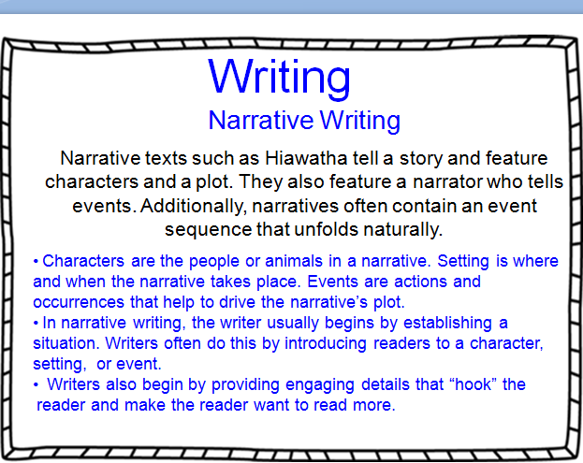
TWO: DIFFERENT QUALITIES OF NARRATIVE WRITING IN FOLKLORE GENRES:
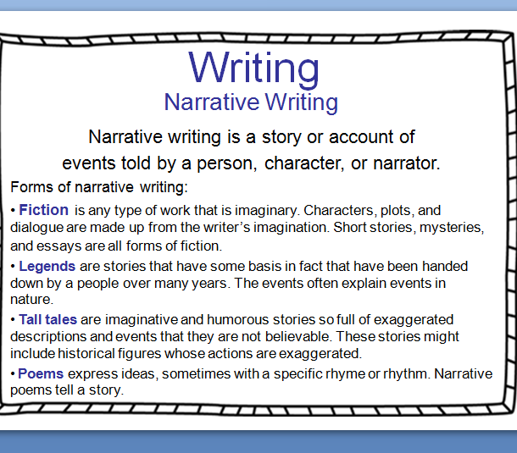
PART THREE: SEQUENCING AND DISALOGUE:
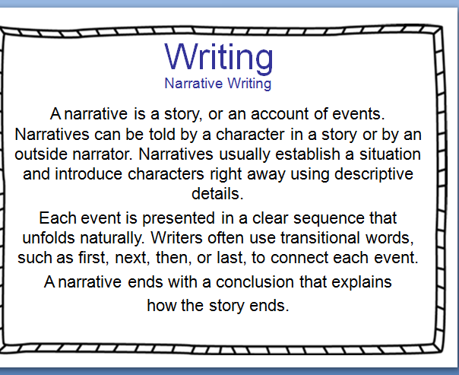
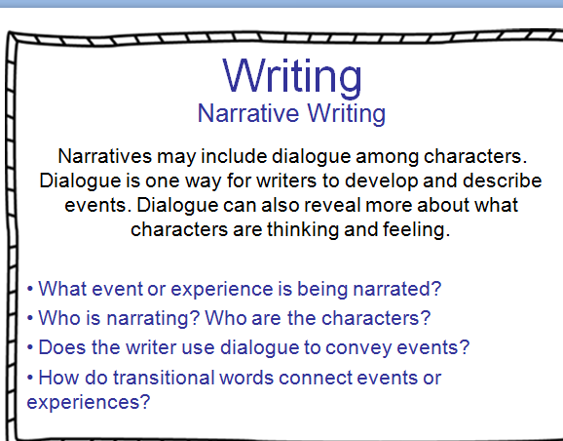
PART FOUR: THEMES-MESSAGES
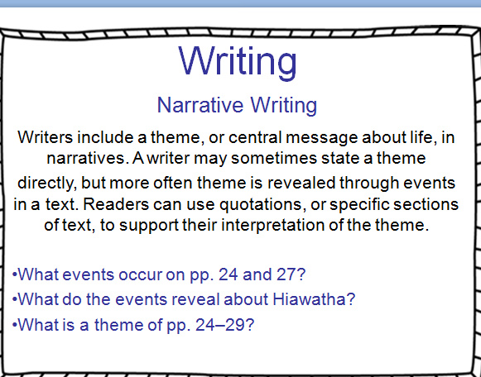
PART FIVE: CHARACTER DEVELOPMENT AND USE OF THIRD PERSON NARRATIVE:
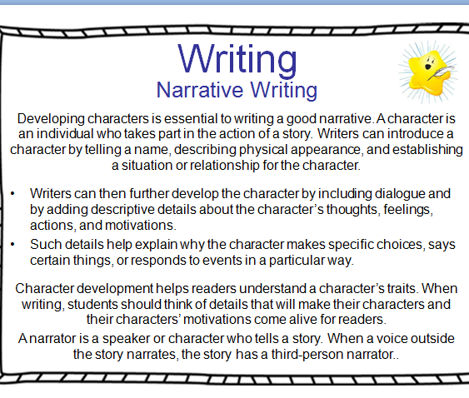
PART SIX: TONE
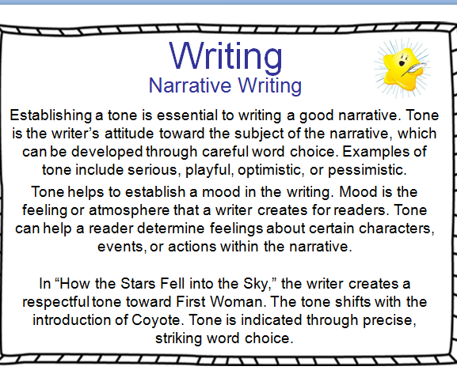
PART SEVEN: USING SENSORY IMAGERY TO DESCRIBE EVENTS:
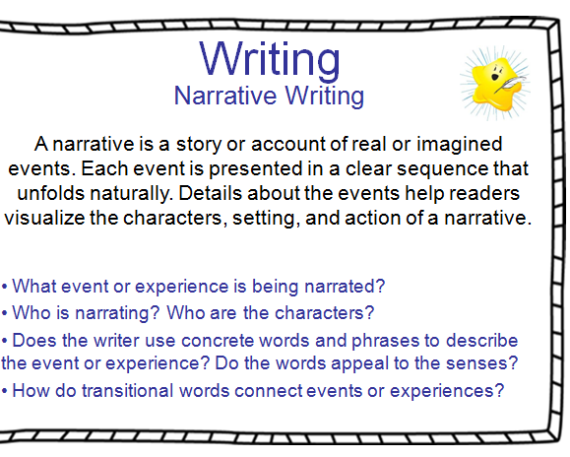
PART EIGHT: SEQUENCING
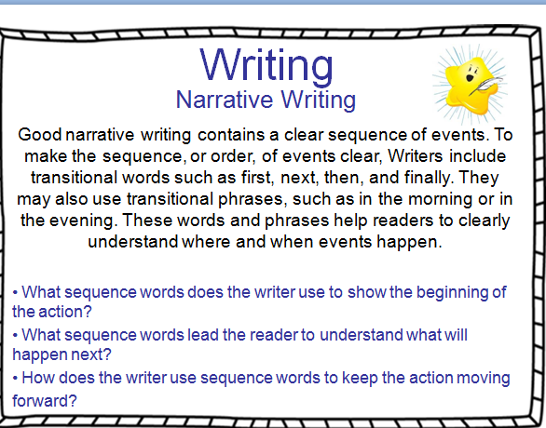
PART NINE: SENSORY IMAGERY
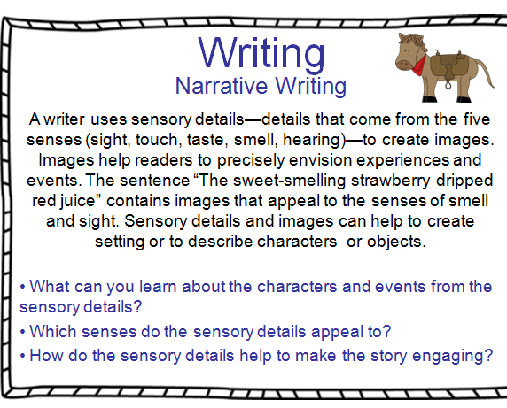
PART 10: USING DIALOGUE
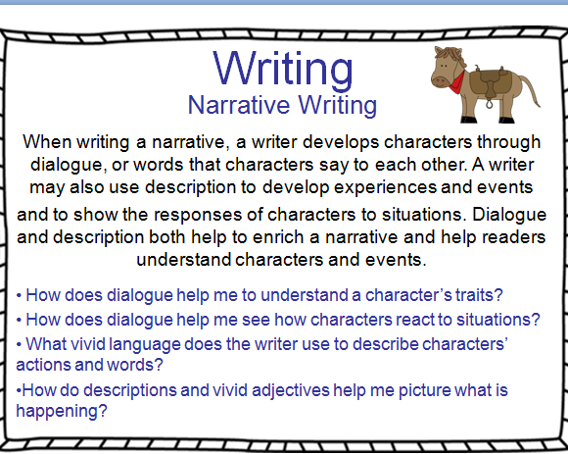
PART 11: INCORPORATING FIGURATIVE LANGUAGE
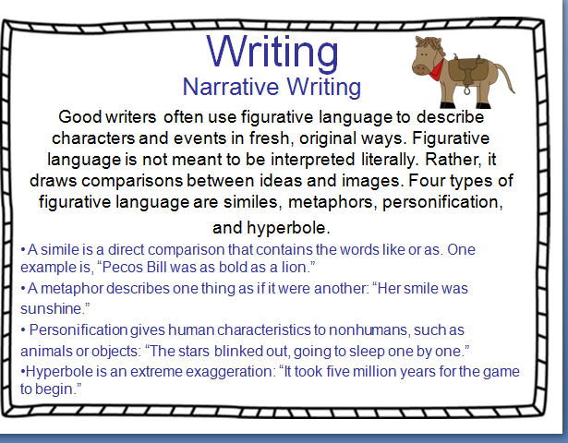
PART 12: CREATING YOUR OWN SWBST STORY CHART
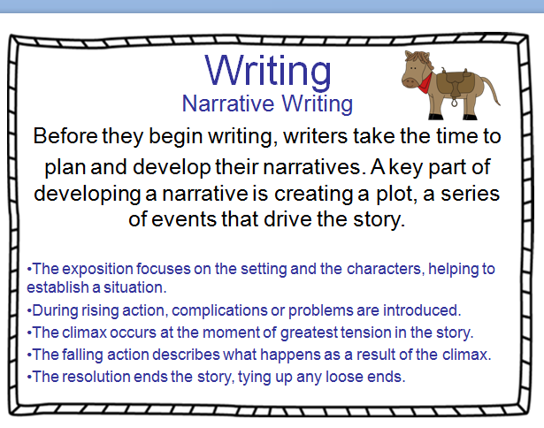
PART 13: CHARACTER AND SETTING DESCRIPTION
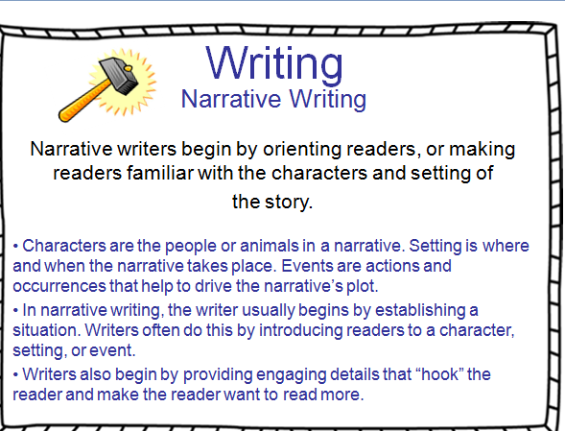
PART 14: REVELAING CHARACTER TRAITS THROUGH DIALOGUE AND EXTERNAL THINKING
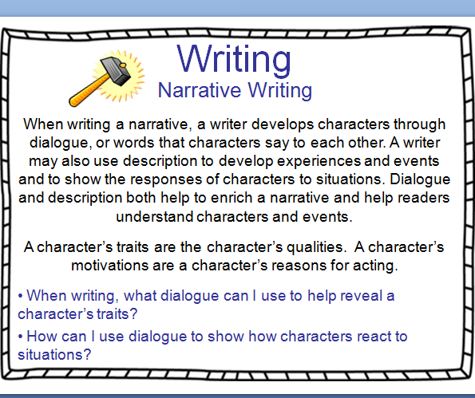
PART 15: KEEPING THE FLOW THROUGH USE OF TRANSITION WORDS AND PHRASES
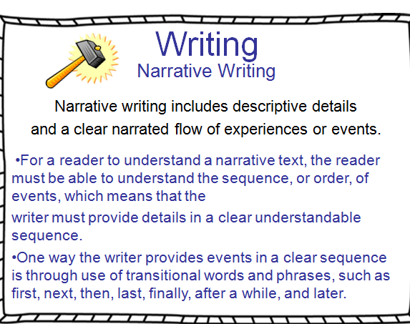
PART 16: CRAFTING A STRONG ENDING
