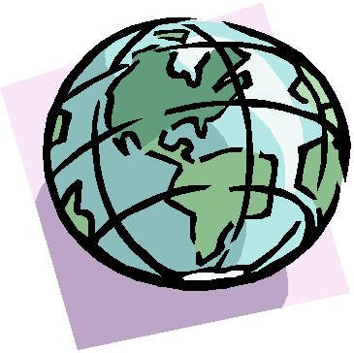
MARVELOUS MAPS PARTNER ACTIVITY
PUBLISHED WORK IS DUE WEDNESDAY, OCTOBER 16 with OUTLINE-FIRST DRAFT DUE THURSDAY, OCTOBER 10. YOU MAY WORK IN TEAMS OF ONE, TWO OR THREE.
USE YOUR KNOWLEDGE FROM OUR UNIT OF STUDY ON GEOGRAPHY AND MAP SKILLS COMBINED WITH YOUR IMAGINATION AND CREATIVITY TO PRODUE AN EDUCATIONAL AND ENTERTAINING PROJECT!!!
Task: Pretend that you are the ruler of a country. First, give your country a name. You may want to choose a theme and have all elements have to do with that theme. For instance, maybe you want to be the king or queen of Candyland, Book land, Harry Potter land, Petland, TV Land, etc. Pull up a throne and prepare to survey your land. As you relax in the luxury of your capitol building, you decide to draw a POLITICAL MAP of your country to be sure it’s all yours. ENJOY! 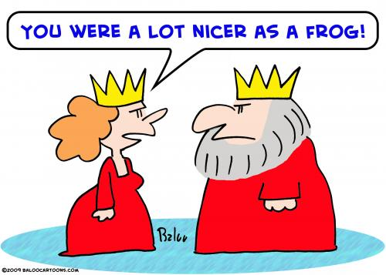
On a large piece of construction paper or oaktag (any color) complete the following:
- Near the bottom of the page, draw your POLITICAL KEY (LEGEND). In it you need to include:
- A SCALE OF MILES (1 inch=100 miles, for instance)
- Symbols for your capital, major cities, the boundaries of your country, boundaries for your state, major bodies of lands (including islands) and water (oceans, lakes, etc).
- Use the symbol for the boundary of your country (international boundary) .
- Title your map: A POLITICAL MAP OF ___________________________
Write your name neatly under the title by ____________________________
- Use your state boundary to divide your country into eight states.
- Write the state name inside each state.
- Since YOU are the ruler—name the capital of your country and place it in one of the states using your symbol for “capital.” You may want to name the capital after yourself but don’t have to.
- Next name four major cities and put them on your map using the “cities” symbol.
- Indicate (label) what bodies of water border your country.
- Draw a compass rose on your map. Include all the directions.
- On the back of your map, write how far it is, in miles from your capital to the nearest border. (Use your scale and show your work).
- HISTORY-Make up the history of your country (how it came to be). Write your history in at least three paragraphs. Make a cover for your history. Put a title, author (you) and a picture on the cover.
- ***Extra Credit: TRAVEL BROCHURE. Use a pamphlet-brochure template to create a travel brochure which will convince tourists to come visit your country.
MAP PROJECT RUBRIC:
4 Completed all steps of map project checklist.
All steps were correctly done
History is clear, well thought out and at least 3 paragraphs using correct punctuation, grammar and spelling are provided.
Travel brochure is included.
Presentation is colorful and integrates technology
3 Completed all steps of map project checklist.
Most steps are done correctly.
History is clear and at least 3 well written paragraphs are included.
Most grammar, punctuation and spelling are correct.
Presentation is mostly colorful and mostly integrates technology
2 Completed most steps of map project checklist.
Some parts are correctly done
History was included but less than three paragraphs long and-or writing wasn’t clear
May include some errors in grammar, punctuation and spelling
- Completed some steps
Few steps were done correctly
No history was included

