WHEN INTEGRATING RESEARCH AND QUOTES IN YOUR ARTICLES:
READ: http://writing2.richmond.edu/writing/wweb/journalism/quotes.html
https://heartifb.com/2013/06/06/5-ways-to-weave-quotations-into-a-feature-article/

- Keep an open mind. Don't assume that you understand all the aspects or parts of your topic. Expect that your understanding will evolve as you report. If it doesn't, you may not have reported thoroughly or aggressively enough.
Once you're ready to write:
- Decide on an approach. Outlining your story is the best way to start. This means reviewing your notes, marking the most interesting or articulate quotes, making a list of important points, and creating a structure into which you can fit your information. Spend extra time of the beginning of your story. Readers will decide whether to proceed based on the capacity of your lede to grab their interest.
- Focus on what's most compelling. Before you start writing, think through all the information you have and all the points you plan to make. What's surprising? What's important? What's useful?
- Show, don't tell. It is tempting to describe a room as messy or a person as nice. But carefully-observed details and well-chosen verbs make a much stronger impression than adjectives.
- Put your story in context. You must help answer a reader's biggest question about any story: Why should I care?
- Don't overuse direct quotes. Sometimes you can best capture a mood with your own prose. Think of direct quotes as icing on a cake -- they enhance, but they shouldn't form the substance of your story. The quotes you do use must be attributed, always. The reader should not have to guess who is talking.
- Fill holes. Are there questions raised by your story that you have not answered? Ask a friend, teacher, editor or fellow reporter to read through your story and tell you what else he or she would want to know.
- Triple-check for accuracy. Spell names right. Get grade levels and titles right. Get facts right. If you are unsure of something and cannot verify it, leave it out. Before you turn in your story, ask yourself these questions: Have I attributed or documented all my facts? Are the quotes in my story presented fairly and in context? Am I prepared to publicly defend my facts if they are questioned?
- Proofread. Do not turn in a story with spelling or grammatical mistakes. If you're not sure of grammar, consult a copy of Strunk and White's The Elements of Style, or read it online at http://www.columbia.edu/acis/bartleby/strunk

Writing the Article
1
Write a hook to open your story. Your first paragraph is your chance to hook your reader and draw them into your story. If the opening paragraph is dry or difficult to follow, you will lose your reader and they won’t continue on to the rest of your story.^{[7]}
Start with an interesting fact, a quote, or an anecdote for a good hook.
Your opening paragraph should only be about 2-3 sentences.
2
Expand on your lead in the second paragraph. While your lead might draw people in, your second paragraph (and subsequent paragraphs) need to start explaining the reason for the story. Why are we reading this story? What is important about it?
3
Follow your outline. You’ve drafted your article in outline form, which can help you stay on track to building a good feature article. The outline can also help you remember how details connect to each other and how quotes support certain points that you’re making.
Be flexible, however. Sometimes when you write, the flow makes sense in a way that is different from your outline. Be ready to change the direction of your piece if it seems to read better that way.
4
Show, don’t tell. By writing a feature article, you have the chance to describe people and scenes to the reader.^{[8]} Describe a setting or person so that the reader can clearly envision it in their mind.
5
Don’t use too many quotes. While it can be tempting to include the interviewee’s own words in the story, don’t rely too much on quoting them. Otherwise, this becomes more of a straightforward interview. Write around their quotes to give them context, build the story and help the reader interpret what the interviewee is saying.
6
Choose language that is appropriate to your readers. Consider the target audience of the publication for which you are writing and write to their level and interest. Do not assume they are familiar with what you’re talking about, so you may need to explain certain things. Be sure to spell out acronyms and explain jargon or slang. Write in a style that is more conversational, rather than stiff and academic.^{[9]}
7
Keep your opinion out of the article. A feature article is a piece that conveys information and detail about a person or phenomenon. It is not an opportunity for you to give your opinion on a topic. Rather, your personality is conveyed through your writing style.^{[10]}
8
Revise your article. Once you finish writing, put the article away for a day to get some distance from it. Come back to it when you are fresh and read through it all the way. Think of ways to sharpen descriptions, clarify points and streamline
explanations. What areas do you need to cut out? What areas need additional information?
- Paraphrase. You can introduce studies that agree with you (Smith 123; Jones and Chin 123) and those that disagree with you (Mohan and Corbett 200) without interrupting your own argument. (Note how efficiently I did that — the parenthetical citations are designed to preserve the flow of ideas in the sentences that refer to outside ideas.)
- Quote Selectively. If you must use the original author’s language, work a few words from the outside source into a sentence you wrote yourself. (If you can’t supply at least as many words of your own analysis of and rebuttal to the quoted passage, then you are probably padding.)
- Avoid Summary. If you must quote several lines of another author’s language, don’t interrupt the flow of your own argument in order to summarize the material you have just quoted. (Generally speaking, summarizing someone else’s ideas is one of the easiest ways to churn out words; while students often turn to summary when they want to boost their word count, paragraphs that merely summarize are not as intellectually engaging, and therefore not worth as many points, as paragraphs that analyze, synthesize, and evaluate.

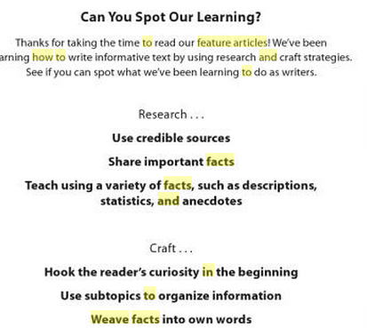

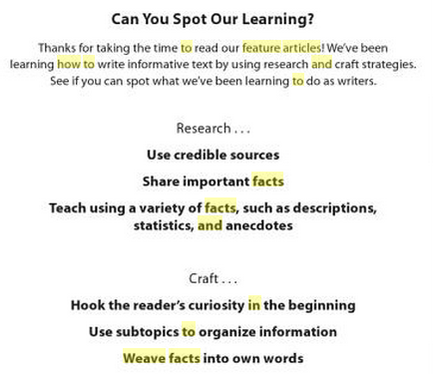

: A story or anecdote is a great way to start your writing. It let’s us hear the character speaking. It makes us feel like we are right there. Today, you will practice writing a narrative lead. Look through your notes and see if there is a brief story that might kick off your piece. The story should be brief and no more than a paragraph or two. First, look through Newsday and find a good feature and describe its lead and why it works. After practice writing a narrative lead and two others. You can later decide which one works best for your feature..
SHARED READING (MENTOR TEXT): http://articles.chicagotribune.com/1995-08-01/features/9508010020_1_rattlers-rattlesnakes-swallow
WHAT IS AN ANECDOTE?
Anecdotes are short, brief stories that create drama. They are used to share information. They are small scenes and used in features for several reasons:
- To make a point without being overbearing.
- To use an example helping to clarify a position or point of view.
- To encourage and inspire others.
- To promote laughter.
- To remember an historical event and or person.
- Anecdotes are used to take factual information and get it to stand up and reveal the essence and heart of your story!
LINK TO FEATURE ARTICLE IDEAS: http://isite.lps.org/akabour/web/FeatureStoryIdeas.htm
FEATURE ARTICLE PRESENTATION:
http://www.slideshare.net/methlal/feature-writing-7683475
ANATOMY OF A FEATURE: http://www.spawn.org/editing/anatomyofarticle.htm
ALSO: BEGINNING:
- IN YOUR FIRST ONE OR TWO SENTENCES TELL WHO, WHAT, WHEN, WHERE AND WHY
- TRY TO HOOK YOUR READER BY BEGINNING WITH A FUNNY, CLEVER OR SURPRISING STATEMENT
- GO FOR VARIETY; TRY BEGINNING YOUR ARTICLE WITH A QUESTION OR A PROVOCATIVE STATEMENT
IN THE BODY:
- GIVE THE READER DETAILS. INCLUDE AT LEAST ONE OR TWO QUOTES FROM PEOPLE YOU INTERVIEWED.
- WRITE IN THE THIRD PERSON (HE, SHE, IT, THEY)
- HOWEVER, KEEP IN MIND THAT YOU WANT TO USE SECOND PERSON NARRATIVE THROUGHOUT THE PIECE AS WELL TO KEEP THE READER ENGAGED (YOU WOULDN'T BELIEVE...)
- BE OBJECTIVE (DON'T COME RIGHT OUT AND STATE YOUR OPINION.--I THINK THIS OR THAT). HOWEVER, YOUR FEATURE IS ANGLED WITH FACTS AND QUOTES THAT DO INDEED SUPPORT HOW YOU FEEL AND HOW PASSIONATE YOU ARE ABOUT SOMETHING.
- USE QUOTES TO EXPRESS OTHERS OPINIONS
ENDING:
WRAP IT UP SOMEHOW (DON'T LEAVE THE READER HANGING)
- PLEASE DON'T SAY, IN CONCLUSION OR TO FINISH (YAWN)
- TRY ENDING WITH A QUOTE OR CATCHY PHRASE
- USE ACTIVE WORDS (VERBS THAT SHOW WHAT'S REALLY HAPPENING)

FEATURE ARTICLE POWERPOINT (WITH EXPLANATION OF A NUT GRAF):http://www.slideshare.net/methlal/feature-writing4832
Link to correct usage of dialogue-punctuation marks: http://www.be-a-better-writer.com/punctuate-dialogue.html
A PLETHORA OF REVISION STRATEGIES:
RULES FOR PARAGRAPHING:
PLEASE FOLLOW THESE AS YOU REVISE YOUR MEMOIRS-When to use paragraphs in narrative writing:
- New characters come along
- New event happens; new idea is introduced
- New setting
- New person is speaking (new paragraph is needed everytime someone speaks and you use dialogue)
- Movement in time (forward or backward)
- Movement in place
Why do we revise?:
: Why do we revise? We must ask ourselves several questions as we go through these stages:
- What is the message or big idea of this piece?
- Where do I get the message across?
- What are the best parts? Be specific. Find best lines or sections.
- Where is it confusing?
- How can it be changed?

