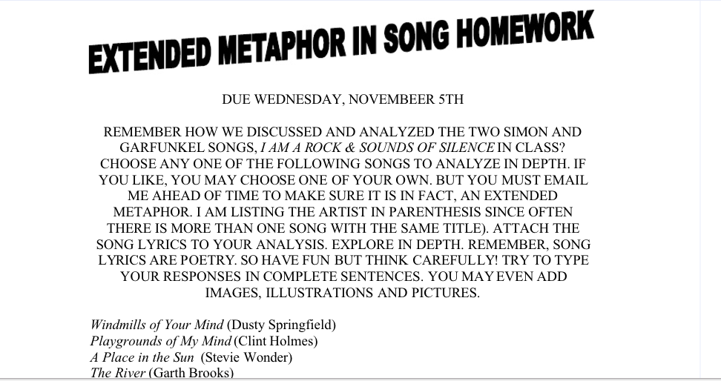
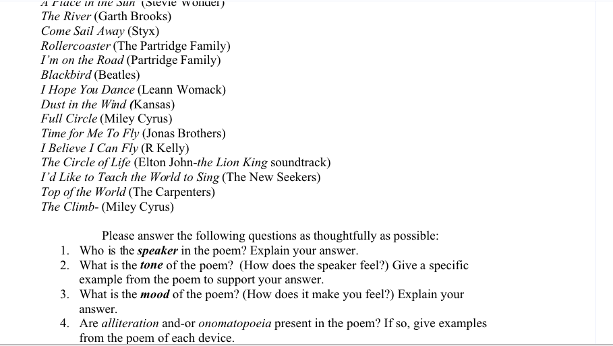

YOU MAY USE ANY SONGS FROM OUR SHOW THAT CONTAIN FIGURATIVE LANGUAGE, TOO.
OTHER SONGS THAT WORK FOR THIS LESSON ARE:
KATY PERRY’S FIREWORK
