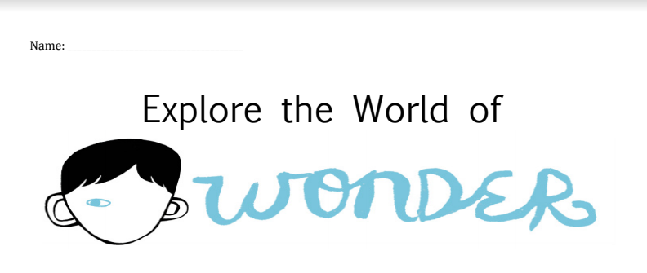
- After watching the video, describe how the author got the idea to write the story.
- After reading the article-interview with the author, write three new interesting facts you learned and tell why you found them interesting.
- In Palacio’s response to the Thank You note on her blog, she says, “My hope is that [Wonder] helps children who look like your son, too, to have a better understanding and more empathy for children like your son.” Do you think Wonder will help children be better understanding and empathetic like R.J. Palacio hopes? Why or why not?
- In the video where you learn about facial differences, Why does R.J. Palacio call Nathanial Newman her “real-life Auggie”?
- After watching the video, write the message, or lesson, it shares with viewers.
- List the two syndromes you chose to research on the Children’s Craniofacial Association’s website along with one fact about each.
- Themes in Wonder: Tell which one you think was most important and why you thought so. Provide at least two examples of evidence from movie or book.
- Which quote was your favorite and why?
- Create a Public Service Announcement
A PSA is a message shared with the public with the purpose to raise
awareness and/or change the public attitudes and behaviors toward an
issue.
- Step 1: After watching each PSA example, respond to the
questions: What message does the PSA send to the viewer—
What do they want you to know or do?
Message in PSA Example 1:
Message in PSA Example 2:

- YOUR PSA
Consider the themes and lessons in Wonder. What message would you like to share with others? Write it below.
Your PSA Message: __________________________________________

____________________________________________________________

____________________________________________________________

Now, consider how you will share your message. You want to create a
PSA that will grab the attention of the audience. Remember in a PSA,
your message should be clear. You can share your message in a
variety of ways. Look over the list below.
How will you share your message? Choose one and circle it.
1. Create a skit (similar to PSA Example 2)
2. Share a small moment story that will engage the audience
3. Use a news story format focusing on facts and information
11. Considering your message, what action would you like your
audience to take? Do you want them to change their attitude
about something? Do you want to urge them to take a pledge? Do
you want them to behave differently? Think about how you want
your audience to change or what you want them to do. Write it
below.

____________________________________________________________

____________________________________________________________

____________________________________________________________

____________________________________________________________
At the end of your PSA, you want to share the message above. This
is called a call to action. A call to action prompts viewers to act, to
do something to change their behavior or attitude. A call to action
could also ask viewers to do something to raise awareness for the
issue described.
Now that you’ve focused on a single message, decided how you
will share your message in your PSA, and identified a call-to-action,
you’re ready to write your PSA. Be sure to stick to the format you
chose (skit, small story, or news format). Turn it in when you are
done writing and proofreading.
RUBRIC:
 | 4 | 3 | 2 | 1
Content: Questions | I answered each question thoughtfully and thoroughly—providing evidence and insight. | I mostly answered each question thoughtfully and thoroughly—providing evidence and insight. | I somewhat answered each question thoughtfully and thoroughly—providing limited evidence and insight. | I did not answer each question thoughtfully and thoroughly—providing little evidence and insight.
Content: Exploring Theme | I chose the most important theme and did an excellent job of supporting my selection with relevant details and insight. | I chose the most important theme and did a good job of supporting my selection with relevant details and insight. | I chose the most important theme and did a fair job of supporting my selection with relevant details and insight. | I chose the most important theme and did not support my selection with relevant details and insight at all.
Creating a PSA: | My script-outline reflect an intentional theme, deal with an important issue and have a strong call to action | My script-outline mostly reflect an intentional theme, deal with an important issue and have a strong call to action | My script-outline somewhat reflect an intentional theme, deal with an important issue and have a strong call to action | My script-outline do not reflect an intentional theme, deal with an important issue and have a strong call to action
Presentation: | All of my work is neat, carefully proofread and contains no or only one or two grammatical errors. | All of my work is neat, mostly carefully proofread and contains only one or two grammatical errors. | Some of my work is neat, carefully proofread and contains some grammatical errors. | Most of my work is not neat, carefully proofread and contains several grammatical errors.

