ENDANGERED SPECIES REMINDERS

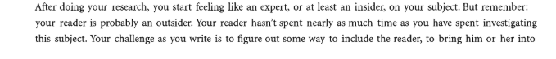:

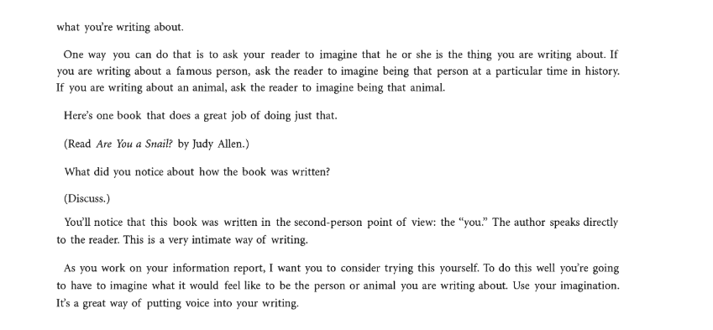

- A lead that is either narrative or begins with an interesting specific fact about why your animal is endangered.
- Transition to nutgraf—what is purpose of your story? What will you teach your readers?
- All about your beautiful animal but start with transition sentence.
- How animal became endangered. Be specific. A minimum of 6 sentences with specific facts.
- The Endangered Species Act and how and if animal is protected.
- Transition sentence –anything else about how animal is being protected. Be specific.
- Big bang ending: Make sure you begin with transition sentence. Revisit closings. Leave us with an interesting thought, idea, question and call for action.

- PLEASE FORMAT YOUR WORK CORRECTLY. IF POSSIBLE, USE TWO COLUMNS.
- DON’T FORGET TO USE HEADINGS AND SUBHEADINGS…THEY SHOULD BE BOLDED.
- CAPTIONS UNDER PHOTOS SHOULD BE BOLD AND A SMALLER FONT THAN REST OF TEXT.
- WHEN REVISING, MAKE SURE YOU DON’T TAKE OUT IMPORTANT INFORMATION, PHOTOS AND CAPTIONS. THEY ARE ESSENTIAL.
- LOOK IT OVER—WOULD I WANT TO READ THIS?
- PROOFREAD YOUR WORK. BE MINDFUL OF WORD CHOICE. SPELL CHECK WON’T CATCH “THERE” OR “ITS”
- LEAVE OUT “I REFERENCES”-TURN THEM INTO YOU OR THIRD PERSON
- PLEASE CITE SOURCES-EXPERTS.
- REMEMBER INFORMATIONAL WRITING IS NOT OPINION WRITING.
- MAKE SURE YOU HAVE AT LEAST THREE DOMAIN SPECIFIC VOCABULARY WORDS WITH DEFINITIONS
- HAVE THREE-FOUR FUN FACTS—NO MORE
- PARAGRAPHS SHOULD NOT HAVE MORE THAN 5-6 SENTENCES.

