Cooking with Fractions 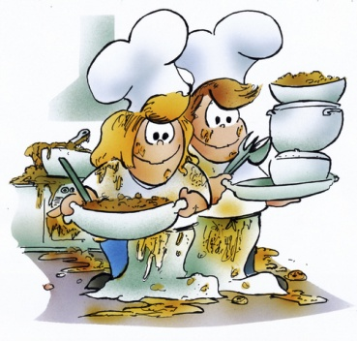
Goal: Convert a recipe to make exactly enough food for our class (30 people). The purpose of this task is to introduce real life problems while reinforcing the concepts of fractions.
Essential questions:
- How can we use all four operations to solve problems with fractions?
- How can we use estimation to determine whether our answers are reasonable or not?
- How can I represent my understanding of fractions?
- How can I use a diagram to support my understanding of the
keep change flip strategy?
- Why do I need to understand the concept behind the procedure?

Role: You are a professional chef catering our class party.
Audience: Mrs. Davis who has hired you to prepare food and the class who will eat your food at the
party
Situation: You have been “hired” by Mrs. Davis to prepare a dish for our class party. Your recipe
needs to be modiﬁed to make exactly enough food to serve each person in our class one serving.
Product: Converted recipe to show how much of each ingredient you will need to make your recipe.
(Actually making food is optional)
Standard: You will be assessed using the attached rubric (which we will modify in class together).
Step 1: Choose Recipe
Go to www.allrecipes.com
Choose a recipe that meets the following requirements (check boxes to make sure that
EVERY requirement is met.
Recipe has at least 6 different ingredients
Recipe contains at least 4 different fractional amounts
Recipe contains at least 2 mixed numbers
Recipe shows original number of servings made
Recipe makes at least 4 servings
Recipe was found on allrecipes.com
Once you have found your recipe, copy the web address and save it on a sticky for future use
Step 2: Set up a Table in Numbers or Pages
Open either Pages or numbers and set up a table like the one below. (Use the same titles
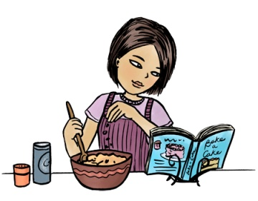
INGREDIENTS | Original Recipe  (serves 8) | Recipe Converted to  serve 1 | Recipe Converted to serve our class  (30 people)
- From your original recipe, enter your ingredients and amounts needed including units onto the
- table
- Now copy and paste the web address of your recipe under your table
- This table will be your “recording sheet” for your ﬁnal answers after you do calculations on a
- sheet of notebook paper
Example of table with original recipe recorded:
INGREDIENTS | Original Recipe  (serves 8) | Recipe Converted to serve 1 | Recipe Converted to serve our class  (30 people)
Flour | 1 cup
Sugar | 1 1/2 cup
Baking Powder | 1 tsp
Salt | 1/2 tsp
ETCETERA

http://allrecipes.com/Recipe/Blackberry-Cobbler-II/Detail.aspx 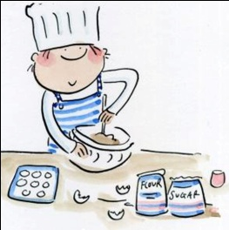
Step 3: How much to serve 1?
- Show all calculations for this step on notebook paper
- Keep work neat and organized
- Label each ingredient
- All answers must be in simplest form
- Take your original recipe and divide the amount needed for each ingredient by the number of
servings that your recipe makes (see my example below for help)
Recipe Conversions: To Make 1 Serving Original recipe makes 8 servings (So I will divide all my amounts by 8)
Flour:
! Original recipe = 1 cup
1÷ 8 = 1/1
÷ 8/1 = 1/1• 1/8 = 1/8cups
Sugar:
! Original recipe = 1 1/2 cups
1 1/2 ÷ 8 = ????continue
Add answers for 1 servings into the appropriate boxes on the table that you made in step 2
Step 4: How much to feed our class (30 servings)?
- Show calculations on notebook paper.
- Keep work neat and organized
- Label each ingredient
- All answers must be in simplest form
Take the answers you got in STEP 3 and multiply these by 30 to get the amount you will need of each ingredient to feed our entire class (see my example below for help)
Recipe Conversions: To Make 1 Serving
If I know how much it takes to make 1 serving then I can multiply my answers from Step 3 by 30 to get how much I need for 30 servings
Original recipe makes 8 servings (So I will divide all my amounts by 8)
Flour: Amount needed for 1 serving = 1/8 cups
1/8x30=1/8X30/1=30/8=3 4/6=3 2/3
Sugar:
This shows where I ﬁlled in my table from steps 3 and 4 for ﬂour
INGREDIENTS |  | RECIPE CONVERTED TO SERVE 1 | RECIPE CONVERTED TO SERVE OUR CLASS (30)
Flour | 1 CUP | 1/8 CUP | 3 2/3 CUPS
Sugar | 1 ½ CUPS
Add answers for 1 servings into the appropriate boxes on the table that you made in step 2
STEP 5: Create at least four fraction word problems based on your recipes—two of which must be fraction division problems.. Be sure to provide an “answer key” that shows and explains how to solve the problem (using CRAW, CUDDLE, four square or another model of your choice). If you really wish to challenge yourselves, make at least one of those problems a multi-step problem).
Step 6: Prepare for Turning In
- Use print view to make sure that your table will ﬁt on one page (see Mrs. Page if you need help
- with this)
- Print your table
- Put your name on all pages
- Read through rubric and grade yourself (rubric MUST be handed in with project with your self
- grade completed)
- Be sure to include a self reflection—one for each member of your group. (Include what you learned, what was most challenging, easiest and reflect back on your new learning).
- Don’t forget to include your word problems with answer key.
- Have entire project ready to hand in at the start of class on the DUE DATE: FRIDAY, APRIL 11TH
~BONUS POINT OPPORTUNITY~
Use your new recipe to make your recipe for our class. You need to bring the
food with you on the project due date to share with the class. You should have
EXACTLY 30 servings to share 1 with each person! This is worth an extra BONUS
of your project grade!

COOKING WITH FRACTIONS RUBRIC:
CRITERIA | 4 | 3 | 2 | 1
RECIPE SELECTION | Recipe meets all 6  checkbox criteria.  Recipe web address  appears under table | Recipe meets all 6  checkbox criteria | Recipe meets at least  4 checkbox criteria. | Recipe meets less than  3 checkbox criteria.
DATA TABLE | Data table created in pages, Word, Publisher or numbers.  Table is neat and  organized. Table  includes units! All data recorded appropriately  on table. Printed on single page. | Data table created in pages, Word, Publisher or numbers.  Table is mostly neat and organized. Table  includes units! All  data recorded on  table. Prints on  single page. | Data table created in pages, Word, Publisher or numbers.  Table is mostly neat and organized. All data recorded on table. May  print onto 2 pages | Table is messy or  missing pieces. Printing  makes table difﬁcult to  read.
DIVISION WORK (CALCULATING ONE SERVING) | All division work  shown on notebook  paper. Work is neat  and organized.  Calculations show  every step.  Calculations all  accurate. Answers  include units | All division work  shown on notebook  paper. Work is  mostly neat and  organized.  Calculations show all  critical steps.  Calculations contain  1-2 minor errors.  Answers include  units. | All division work shown  on notebook paper.  Work is legible.  Calculations show  some steps.  Calculations contain  3-5 errors | All division work shown  on notebook paper.  Work is messy  Calculations missing  critical steps.  Calculations contain
MULTIPLICATION WORK (CALCULATING 30 SERVINGS) | All multiplication work  shown on notebook  paper. Work is neat  and organized.  Calculations show  every step.  Calculations all  accurate. Ans | All multiplication  work shown on  notebook paper.  Work is mostly neat  and organized.  Calculations show all  critical steps.  Calculations contain  1-2 minor errors.  Answers include  units. | All multiplication work  shown on notebook  paper. Work is legible.  Calculations show  some steps.  Calculations contain  3-5 errors. | All multiplication work  shown on notebook  paper. Work is messy  Calculations missing  critical steps.  Calculations contain  more than 5 errors.
WORD PROBLEMS | You created at least four fraction word problems—two of which are division word problems based on your recipe. At least one of those problems is multi step. You include an answer key that shows all of your work (using CRAW, CUDDLE, Four square or another method you select). | You created at least four fraction word problems—two of which are division word problems based on your recipe. You include an answer key that shows all of your work (using CRAW, CUDDLE, Four square or another method you select). | You created fewer than four fraction word problems—two of which are division word problems based on your recipe. You may or may not have included an answer key that shows all of your work (using CRAW, CUDDLE, Four square or another method you select). | You created fewer than two fraction word problems—two of which are division word problems based on your recipe. You did not include an answer key that shows all of your work (using CRAW, CUDDLE, Four square or another method you select).
WRITTEN RESPONSE | Each step is carefully explained and labeled. It uses math vocabulary words. Afterwards, you carefully and thoughtfully reflect back on what you learned, what was challenging and what was easy . | Each step is mostly carefully explained and labeled. It uses math vocabulary words. Afterwards, you mostly carefully and thoughtfully reflect back on what you learned, what was challenging and what was easy . | Each step should be more carefully  explained and labeled. It uses math vocabulary words. Afterwards, you need to more carefully and thoughtfully reflect back on what you learned, what was challenging and what was easy | Your work is not carefully explained and labeled. It doesn’t use math vocabulary words. You did not carefully and thoughtfully reflect back on your learning.

