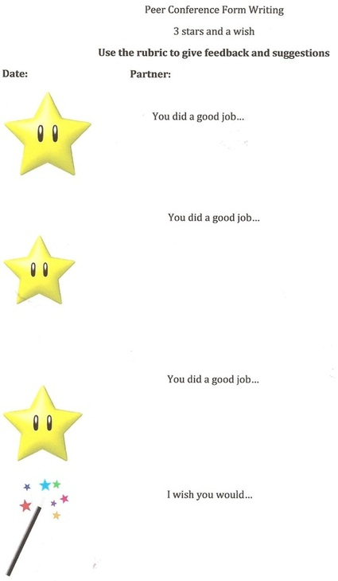

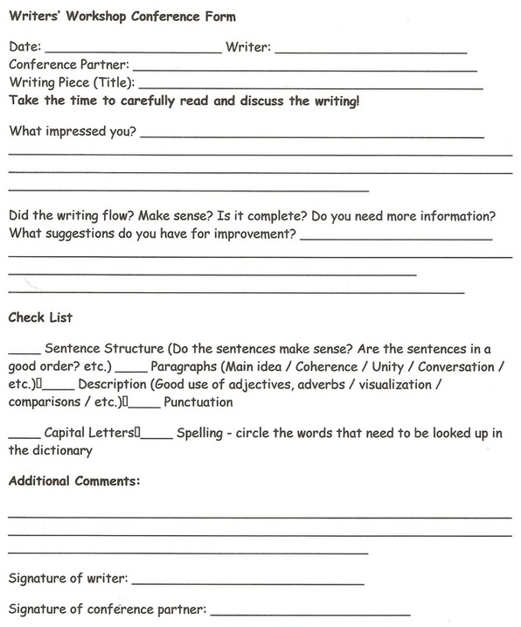

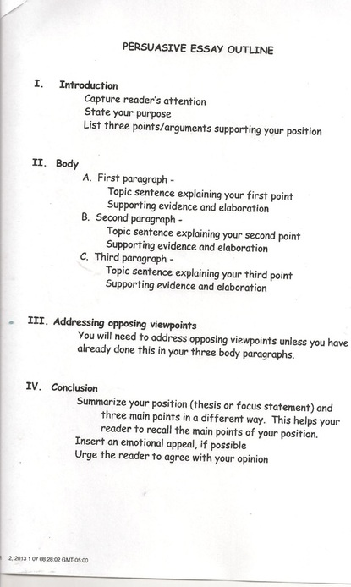

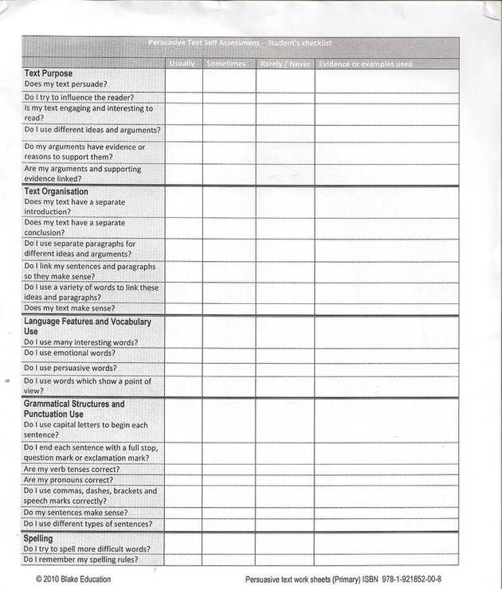

SELF-EVALUATION-EDITORIAL
Neatly and honestly answer the following questions about your editorial after you’ve written the final draft. Answer in complete sentences:
- After studying this genre for the past several weeks, what would you say a author has to think about to write a good editorial?
- What ARGUMENT were you trying to get across in your editorial?
- How did you get your argument across to your readers?
- Which mentor texts did you use to help you write your piece? How did they help you?
- Who is the audience for your piece? Where do you imagine your piece being published?
- What is the tone of your editorial? Give an example of how you best present it to us.
- Give an example of how you best incorporated your writer’s voice into your editorial.
- What is the best thing about this editorial?
- Where could you have improved it?
- What did you learn about yourself as a writer in this unit?
- What is your favorite new writing strategy you learned and how did you use it in your writing?

